**Diamond Nine**

The Diamond 9 exercise is an interactive and engaging activity designed to help individuals reflect on and prioritize various elements related to their career choices, personal values, or skills. It's particularly useful in career counselling or personal development scenarios where one needs to evaluate what truly matters to them in a job or career path.

It is useful for career decision-making due to:

**Self-Reflection**: It helps individuals understand their priorities, values, and skills in the context of their career aspirations.

**Skill Assessment:** Identifies which skills one possesses, wants to use, or wishes to develop further.

**Decision-Making:** Assists in making informed career choices by visually organizing and prioritizing different factors.

**How to Use the Diamond 9 Exercise for Career Exploration:**

Identify Factors. List nine factors or elements related to career choice. These might include:

* Job satisfaction
* Salary
* Work-life balance
* Use of current skills
* Learning new skills
* Job security
* Location
* Company culture
* Contribution to society

Now write them down on bits of paper and organize them into the diamond 9 shape as per below:

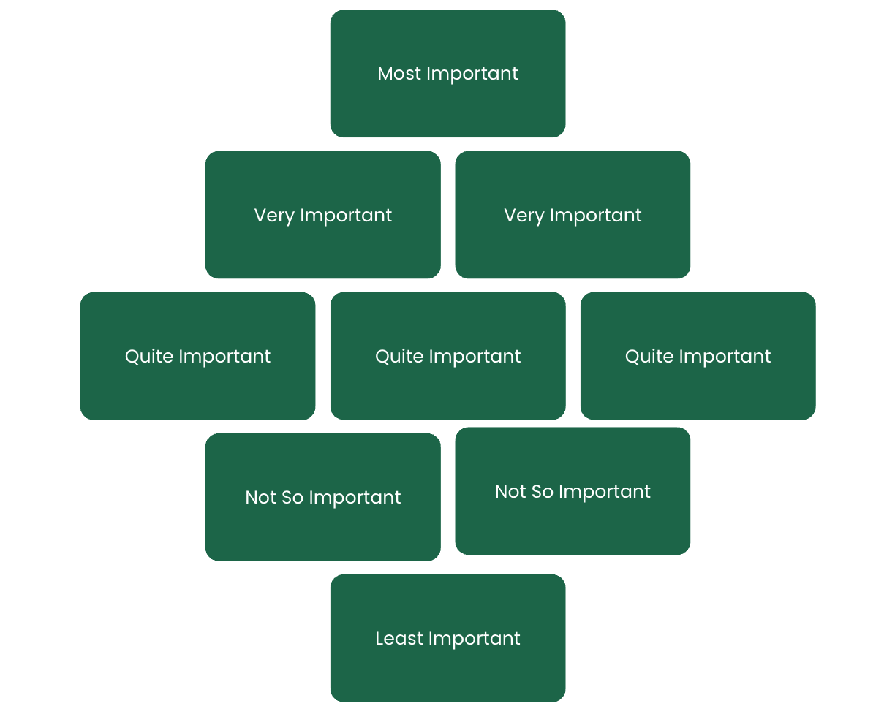

Once you have prioritized your factors, reflect on why you placed each factor where you did. This can be done alone or discussed with one or more of your supporters.

If you're with others, debate the placements. This can lead to new insights or a reevaluation of priorities.

After discussion or reflection, you might want to rearrange some factors. This step is crucial as it often leads to a deeper understanding of one's priorities.

Based on the final arrangement, consider how these priorities affect your job search:

Look for roles where you can use or develop the skills you value.

Consider industries or companies that align with your top priorities.

Think about what compromises you might be willing to make for less important factors.

You can also try this technique for identifying the skills you have and enjoy which can lead to a better understanding of the type of work you want to do.

List the skills you have, hard and soft. Then arrange them into the diamond 9 shape and follow the same process.

